Here is a set of six fractions:
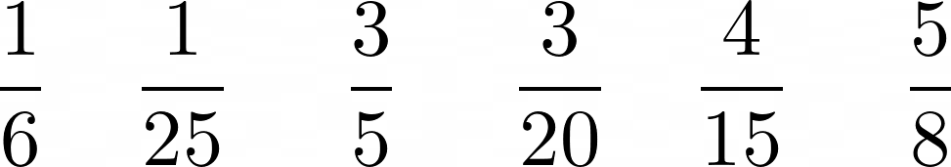
Choose some of the fractions and add them together. You can use as many fractions as you like, but you can only use each fraction once.
Can you get an answer that is close to 1?
What is the closest to 1 that you can get?

